Welcome to the Start Up Manual
Tri Star Rogue XL Series of
Bioelectronic Devices from
Earth Glows LLC, USA

Be sure to visit our website at: www.earthglows.net

CONTACTING US:
You can contact me – Gene Robbins – directly at: earthglows@yahoo.com
> I’m very limited in what I can send over to your inquiries if you use eBay, they do Not allow email or web addresses.

The Rogue Systems are very simple to operate with no user parts. These units are frequency-controlled Drivers that use pulses of High Voltage Static/ Micro-Ampere pulses to drive Plasma, Magnetic & Static devices in different configurations.

Currently there are (3) XL Systems available: The XL (D) & (P) Plasma Driver and the XLD Mag Driver.

> This Manual covers the XL (D) & (P) Plasma Driver only to avoid User confusion

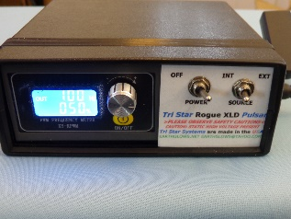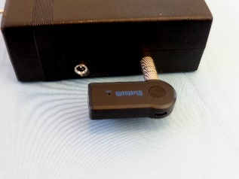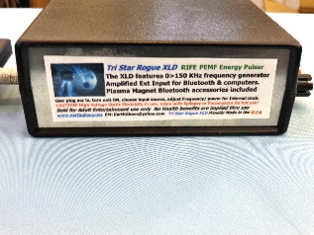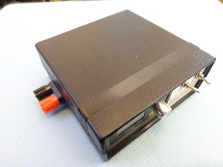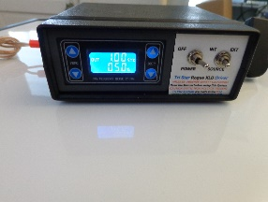
XLD Bluetooth Rear Panel Side Panel XLD
Knob Version Pushbutton

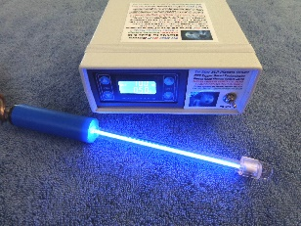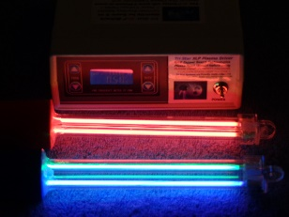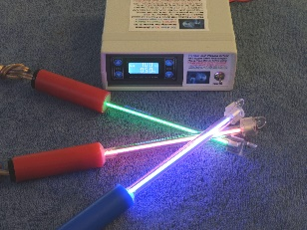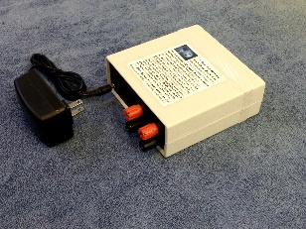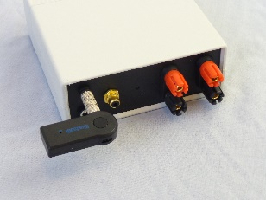
XLP (2) Dual Tubes 3 Color Plasma Rear Panel Rear Panel
Standard IO Version

The XLD Model was replaced by the XLP Model on June 1/ 2022

XLD Highlights: single channel output, will run single Plasma tubes only, comes with External Input & Bluetooth

XLP Highlights: dual channel output, will run (2) Plasma tubes or dual tubes – 4 tubes total, Optional IO Package W/ Ext/ Bluetooth and SO (signal output) -- used for ‘daisy chain’ operation of multiple units.

Programs/ Frequency Control:
These units feature a built-in 0 > 150 KHz frequency generator with adjustable power for on-board frequency control.
Currently there are (2) control versions – knob control and pushbutton. The Knob type generator is being phased out in favor of the push-button design. The push-button units are less confusing for some customers, but the Knob can change values quickly.

Start-up:

>> NEVER USE ANY POWER SUPPLY BUT THE ONE SUPPLIED WITH THE XL unit!

XL’s ship with the setting at 10 Hz & 50% so the Plasma should light immediately. Turn the unit on and adjust the frequency with the left side buttons/ [ FREQ ] and for the power adjust the right-side buttons/ [ DUTY ]. For systems using the knob – turn the knob to adjust for DUTY and push the knob in to switch to frequency adjustment.
The DUTY should be between 5 > 65%. NOTE: Visors usually start at 5% DUTY.

Insert the power supply into a live wall socket.

Plug the power jack into the unit.

Turn the unit 'ON' and the dash lights should light up.
> if not check the jack going into the unit by turning it and making sure it is all the way in - sometimes they are stiff at first.

Turn the unit 'OFF' and plug (1) Plasma into the unit.

Confirm the far-right toggle switch is to the LEFT position at 'INT' (XLD & XLP IO units)

Turn the unit back on and if the dash is lit then the plasma will flash at ~ 10 Hz and 50% duty.

NOTE: for solar/ battery powered devices you can skip plugging into a power supply if the battery is charged. The solar cells will charge the unit at the same rate you use it, so 4 hrs use needs 4 hrs of direct Sun.

INT INPUT:
All XL Systems come with a 0 > 150 KHz frequency generator that also has an adjustable DUTY cycle. The DUTY controls the width of the actual pulse so 10 % means that the Pulse is 1/ 10th each frequency cycle. A 50 % DUTY means that you get a pulse that is ½ of the frequency cycle. This is also known as PWM/ Pulse Width Modulation and is used in most motor controllers and countless other applications as a simple method to adjust the power output at different frequencies.

NOTE: For specific high frequencies we recommend use of an EXT frequency generator to fully drive the Plasma. At frequencies of ~ 200 KHz and above – the DUTY should be raised up to 97% to compensate for Plasma roll-off at the higher frequencies.

EXT INPUT:
> Important! Make sure you are sending a sawtooth/ square wave signal – the units will Not trigger on sine wave.

When using the EXT input – you can control the Plasma intensity thru the volume control on the computer/ cell phone or the signal strength of a frequency generator. Plasma may appear dimmer then when used with the internal FQ generator, adjusting the loudness control can correct this.

EXT Input: ^ 300 KHZ Plasma!
For commercial or custom programs of frequency ( meditation & Rife ), the EXT input jack ( subminiature stereo jack ) is an amplified external input designed for low level inputs from Bluetooth, desk computers, frequency generators & others.

> All XLD units come with matched Bluetooth receivers so outside software can be used.

> When using an External FQ generator or software – always check the different wave forms for best power level. Different software, free FQ generators and some lab FQ units will deliver different signal strength into the XLD and that affects Plasma strength.

- Remember your volume levels across all of your devices involved will affect signal strength.

> Important! Make sure you are sending a sawtooth/ square wave signal – the units will Not trigger on sine wave.

NOTE: when using the External input, the frequency/ DUTY controls have no effect on EXT signals
Make sure you have the volume on the transmit unit turned to MAX so the Plasma will be at its brightest.

As you get farther away from the transmitter, the signal will get weaker, and the Plasma will get weaker, so you will want to stay close to the transmitter.

External Audio:
To hear audio of any program you are running simply run the Bluetooth signal to a second audio receiver – most BT units have dual channels.
Switch the toggle over to the EXT position. The EXT input has a pre-amplifier circuit so if you are using an external frequency generator, keep your input signal ~ 3-5 volts. If you overdrive the input, you WILL get a distorted output from the XLD.

> a frequent problem with just plugging an EXT source into the unit is that your plug is wired wrong for the XLD jack. This is why you use the Bluetooth first as we know that works.

Always be aware of static shock – the base XLD runs ~ 1KV micro-ampere pulses, harmless but still a static shock – Always turn the unit OFF before switching accessories.

Problems & Issues:
While we worked hard to make the operation of the XLD as simple as possible – it is still a complex device with a lot of uses. First time users sometimes have issues over getting the units to work for them. The following are examples.

NOTE: The power jack and the Bluetooth receiver jacks may need to be twisted and re-plugged in when first used after a long storage time.

Bluetooth Startup:
Using Smart phones for the Bluetooth. I know people love their smart phones, but we strongly suggest you use a desk/ lap computer - the audio output is much stronger, and you want a strong Bluetooth signal to get a strong output on the XLD - brighter Plasma & stronger film pulses.

We test each unit as a complete system from the power supply to the Driver to the Plasma.

We also test Each Bluetooth with the corresponding unit, so we know everything together works perfect.
However, Bluetooth can be tricky at first so here are some suggestions if you have issues.

First, is the Bluetooth charged?
> when you plug the WIFI receiver into a charger, you should see a Red LED which means it is charging. The Blue LED will light when the unit is charged. Charging can take upto ½ hr.

> turn the transmitter ON
> Make sure you get a flashing Red & Blue LEDS when you press the ON button. Red & Blue flashing together means the BT is searching for a signal.

- make sure you turn on the signal source
> turn on the BT receiver
> place the receiver next to the transmitter until they lock
> plug the receiver into the XLD unit
> turn the XLD unit ON

> check XLD operation first using the Internal FQ generator

Last – push the right-side toggle to the right [EXT] setting

> The pairing make take 10 > 15 seconds and we suggest that you start transmitting and Then turn the XLD Bluetooth on. You can place the receiver next to your transmitter unit until it pairs and then plug it into the XLD.
------

Next, confirm the XLD is working correctly.

1. First make sure there is power to the unit – does the dash light up when the power is switched on?
2. Make sure the far-right toggle switch is set to – ‘INT’ or the Plasma will not light without EXT input.
3. Make sure the DUTY is set ~ 50%, if set at ‘0’/ zero or the Plasma will not light.
4. Make sure the Frequency is set above ‘0’/ zero or the Plasma will not light.
5. Carefully inspect the Plasma for cracks or breaks in INNER glass tube.
If none of these work, then contact us immediately and we will offer other solutions.

> Each of the XLD Systems are tested as complete units before they are shipped but damage can happen in shipping.

Next, we suggest you send your Bluetooth signal to a separate receiver like a speaker to make sure you are sending out.

Free Frequency Programs:
There are lot of frequency software available for users. We recommend (2) Free sources to use.

For Rife frequency: we strongly recommend FreX16 software down-loadable as Free Trial. FreX16 is the most widely recommended and we have dealt with in-depth Lyme disease patients and clinics who have had solid results using their programs. You can program your own programs, Australia based - solid on research.

https://www.google.com/search?q=how+to+use+FreX16&oq=how+to+use+FreX16&aqs=chrome.0.69i59.8517j0j7&sourceid=chrome&ie=UTF-8

> FreX runs well on the XLD but again we advise you to use saw-tooth.

Fixed Frequency: there are several sites that offer free software. We like [ SZYNALSKI.COM ]. Simple to use Free software with nice features. You can generate multiple frequencies by opening the program under another tab.
> they have .01% frequency resolution for users who want exact frequency. (support sites like this)

https://www.szynalski.com/tone-generator/
> use sawtooth shaped pulse

NOTE: most of these programs work best using the ‘Sawtooth’ pulse configuration. Sine wave will Not trip the Plasma and a lot of square wave will trigger double pulses. To verify your external frequency input (frequency generator) - compare it to a low frequency input from the on-board generator at 2 Hz, you will quickly see any frequency difference.

Accessories:
The XLD Family of accessories covers the (3) basic forms of Energy known to influence the Human body. Plasma, Magnetic & Static films.

NOTE: This Manual Only covers the Plasma & FluxFilms accessories. The XLD Plasma Driver is not recommended for use with the MagStrobe accessories.

Plasma:
Our Plasma come in (4) colors of Blue, Green, Red & white.

Plasma (PLZ) comes in:
> (2) length’s: 6”/15cm & 12”/ 30cm
> single & dual tube assemblies
(larger arrays are available)

XL Series Plasma come in (2) configurations:
Plasma (W): is a wire wound style. The Plasma is wound with wire for (2) reasons, first the windings create a magnetic field at the tube surface and second it creates a Zero Point Energy (ZPE) field. ZPE comes from Quantum Mechanics Theory and is believed to be the cause of Photon emissions from an energized Ion field – Plasma.

NOTE! Never use a wired Plasma with a FluxFilm or you will receive a static shock.

Plasma (T): The T style is used with a FluxFilm (static field) to transmit the Energy pulses THRU the body in the same fashion as a RIFE Plasma tube transmits from a plasma thru the body.

To use transmitted energy, you plug only (1) Plasma banana jack into the XLD, and you plug a FluxFilm into the other jack. By placing your hand on the film and bringing the Plasma in contact with a body part – you will see the Plasma become significantly brighter. You can use this process on any body part, but we suggest you avoid use directly to the head area.

T Plasma can also be run like the W versions were both plugs are jacked into the Driver for Maximum brightness.

Application: Plasma tubes are applied directly to the skin. For deep Meditation, they can also be placed across the forehead to maximize the E-Field across frontal lobes and the pineal gland/ 3rd Eye.

Plasma does not create a magnetic field, but it does create a large Electric field called an E-Field. The XLD Plasma requires ~ 1000 volts to ignite. The gas inside the tube will increase in voltage until the breakdown voltage of ~1000 volts is achieved at which time the gas conducts the electricity and turns into a Plasma. The Plasma causes the electric field to drop back to zero/ ground level extremely fast. This fast rise and then very fast drop in voltage creates a strong Electric field pulse.

It is this sharp pulse in the Electrical field that permeates the body to a depth of upto 12”/ 30cm as measured with Lab equipment. This pulse directly influences a number of cellular states by interacting with the ion balance of the cell. Some cells are more susceptible to this energy – cancer for example is known to be very susceptible to Nano second pulsed E-Fields at very high voltage. The XLD Systems are not designed for cancer treatment as the voltages are below the needed threshold.

Plasma - High Frequency & Cold:
Plasma runs best if it is warm. For both High Frequency and cold Plasma tubes – operation may be poor or not at all if the tubes are cold. This is common with all gas discharge devices. Running high frequency or multiple Plasma tubes are even more prone to poor performance if the tubes are cold.

We recommend at least 5 minutes of operation at 100% to allow optimum temperature for good performance.

Restarting Plasma:
Plasma always runs best after it is warmed up for 5 minutes at least. If the Plasma drops out at higher frequency – reduce the frequency to ~ 10 KHz and then increase back up. When a Plasma goes out at very high frequency – you need to reduce the FQ to get it to re-ignite.

FluxFilms:
DO NOT PLACE FluxFilms ACROSS THE CHEST or HEAD!

ALWAYS START Static films at 5% DUTY cycle to avoid static shock.

FluxFilms, also called ‘static films’ are based on the well-known electrical effect called ‘Dielectric Transfer.’ When 2 conductors like aluminum foil and Human tissue are separated by an insulator (plastic laminate), electrical signals and Energy can pass between the 2 conductors If the Energies are Alternating current. A dielectric cannot pass a Direct current only a signal that changes in voltage polarity.

Because of this effect, you can pass a High Voltage static electricity signal into and thru the body without getting a shock if you use a large area to spread out the current across the tissue.

FluxFilms are popular because the HV static charge will pass thru the body. Low voltage devices like a TENS device for pain have very limited penetration into the body because there is electrical resistance in the skin & tissues that will reduce the signal down to zero.

This is the main reason that TENS devices are limited to just below the skin surface. This also applies to any device using handheld conductors like copper pipe and low voltage like battery powered Zappers.

FluxFilms & (T) Plasma tubes:
This effect is used to transmit Energies directly between the body and a T Plasma tube. The FluxFilm is placed on the skin where it energizes the body tissue. When a T Plasma with Only (1) jack plugged into the Driver comes close to the body – the Plasma will brighten. The Plasma will glow dimly at several feet away but direct contact with the skin will cause it to brighten a lot.

> Always start Flux Films at 10-20% and test for discomfort before raising the power level to avoid a static shock. The Flux Films are used to apply the pulsed electrostatic pulses to various places on the body. You place the films opposite sides of the arm or legs or hand to hand like regular handhelds. These films operate by using dielectric transfer between the foil and the skin.

Treatments & Programs:
DO NOT PLACE FluxFilms ACROSS THE CHEST or HEAD!

General Notes-
NOTE: the FreX16 software allows you to create your own programs of frequency and duration – it is really not that hard to do. If you find that you like certain frequencies for different treatment times, we strongly suggest that you build your own programs. This is especially true for Meditation and pain mitigation.
Most non-program treatments use single frequency and power, and a lot of users will run the accessory for extended periods of time. All day and/ or all-night operation is common, but most studies show that ½ > 1 hour duration works best and then a repeat of the process. You have to let the cells return to their ‘balance state’ before you can influence them again. In other words – repetitive treatments seem to work better, and extra treatment length does NOT necessarily mean better results or longer lasting results.

Meditation – Using Plasma
The XLSeries is designed for low frequencies in the Brainwave range of 0 > 100 Hz. By using the DUTY/ % adjustment you can extend or shorten a pulse from 1 > 100% pulse duration – 100% DUTY is ON and not a pulse. Most Meditation is in the 40 > 50% Duty cycle.

Alzheimer’s & 40 Hz:
The MIT/ Cognito technology of using light & sound pulses centered around 40 Hz shows great promise in directly affecting brain chemistry in a controlled fashion. There is a range of pulsed frequencies under study that show direct results on brain chemistry based on frequency and Duration.

Memory and Mental acuity:
As with Meditation, studies continue to show significant – measurable improvements in Brain function when using controlled visual stimulation.

> the basis of most of these studies involves ‘Entrainment’ of the brain to produce specific Brainwave patterns or frequencies. While Entrainment has been known for a long time (think musical rhythms), actual measurement of results is recent. Most studies start on animals (rodents) and then move to clinical Human studies once parameters of effects are better known.

Muscles - aches/ pain
NOTE: when placing static films across a leg or arm, you may experience muscle contractions at low frequency/ < 50 Hz. People use this technique to improve circulation and increase muscle tone. Both Plasma and the FluxFilms are used for both pain and skin/ sub-surface stimulation. Red Plasma is the most used and both the ZPE wound Plasma and the direct contact Plasma work well for most people. Most muscle-based programs are low frequency, but users have reported excellent results using direct contact Plasma & FluxFilm at 80 > 100 KHz.

RIFE Frequencies: See FreX16 software

Specific Health issues:
For general treatments we recommend using Frex16. This software has a very large listing of most health issues, and each program has the frequencies and duration included so all you have to do is load it and then run it thru the XLD. There are many frequency programs on the market and some like Solfeggio frequencies are very well known and widely used. The XL units works particularly well with programs like Solfeggio when a quality audio program is also used to pulse the Plasma using the Bluetooth accessory.

WARRANTY:
There are no user serviceable parts on the Rogue Series. If the unit fails within the 6-month warranty, Earth Glows will either refund the full amount of the purchase cost plus any shipping costs after the return unit has been shipped or we will repair/ exchange the unit within 24 hrs of return of the defective unit.

Plasma tubes do not carry any Warranty. We test each tube before shipment to ensure 100% operation, but we cannot offer any guarantee because they are easy to break in use. Care must be taken not to drop or bend the tubes, or the inner glass tube will break, and the Plasma will not light.

Earth Glows LLC is a US company and subsidiary of the Andromeda Laser Grp (est. 1980). Our systems are USA made. Our technology is partly based on 40+ years’ experience & (3) US Laser Patents building large - pulsed gas lasers.

Website: www.earthglows.net Contact: earthglows@yahoo.com
---------------

The following is collection of articles. Earth Glows uses Technology that is Science based. Some of these articles get very Technical but Earth Glows LLC uses US Laser Patent Technology in designs so we are very technical based.

Reference Articles:
https://www.alzforum.org/news/conference-coverage/does-synchronizing-brain-waves-bring-harmony#Flicker

https://www.fiercebiotech.com/medtech/cognito-s-light-and-sound-therapy-slows-alzheimer-s-declines-clinical-study

https://www.youtube.com/watch?v=wDZgzsQh0Dw&ab_channel=TEDxTalks

https://www.ncbi.nlm.nih.gov/pmc/articles/PMC3222307/
Effects of pulsed energies on HIV

https://www.ncbi.nlm.nih.gov/pmc/articles/PMC3776323/
Electrical stimulation to accelerate wound healing

https://www.ncbi.nlm.nih.gov/pmc/articles/PMC5574357/
Results on benign prostatic hyperplasia

https://www.ncbi.nlm.nih.gov/pmc/articles/PMC5992548/
Effects of PEMF on arthritis and inflammation of joints

Research Articles on Pain & Pulsed Electric Fields/ visual light
(2/ 10/ 2022)

https://healthquest.us/treatment-options/super-pulsed-laser-therapy-reduces-pain/#:~:text=Laser%20therapy%20(also%20known%20as,inflammation%20and%20give%20pain%20relief.

https://clinicaltrials.gov/ct2/show/NCT03677206

https://laserneuropathypaintreatment.com/common-questions/
------
https://pubmed.ncbi.nlm.nih.gov/18240331/

http://www.aerotel.co.il/files/docs/A_pulsing_electric_field_increases_human_chondrocyte_proliferation_through_a_transduction_pathway_involving_nitric_oxide_signaling.pdf
------

https://pubmed.ncbi.nlm.nih.gov/34208945/

